SVN Merging
- Open Windows Explorer and open the source folder of your local working copy of MLib
C:\APPL\mlib
- Right-Click on the folder and select TortoiseSVN -> Merge
- Select Merge a range of revisions then Next
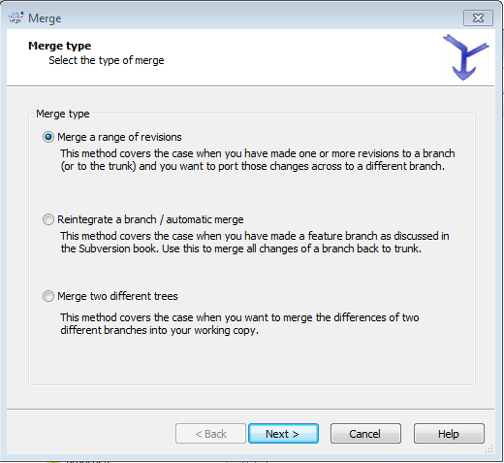
- Enter the URL for the Trunk then select Next.
Enter specific revision numbers if required in the white box labelled specific range ( if required )
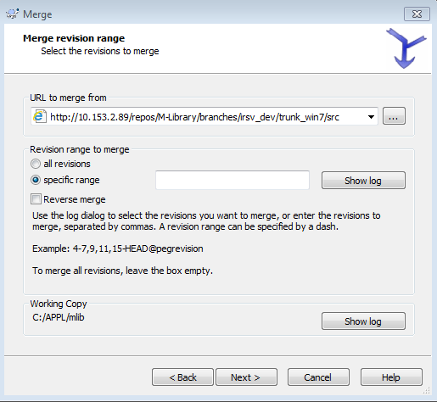
- Finally select Merge
